What is Infrastructure?

Infrastructure as Code (IaC) is a widespread terminology among Devops professionals. It is the process of managing and provisioning the complete IT infrastructure (comprises both physical and virtual machines) using machine-readable definition files. It is a software engineering approach toward operations.

**Terraform Core concepts**

Below are the core concepts/terminologies used in Terraform:

* **Variables**: Also used as input-variables, it is key-value pair used by Terraform modules to allow customization.
* **Provider**: It is a plugin to interact with APIs of service and access its related resources.
* **Module**: It is a folder with Terraform templates where all the configurations are defined
* **State**: It consists of cached information about the infrastructure managed by Terraform and the related configurations.
* **Resources**: It refers to a block of one or more infrastructure objects (compute instances, virtual networks, etc.), which are used in configuring and managing the infrastructure.
* **Data Source**: It is implemented by providers to return information on external objects to terraform.
* **Output Values**: These are return values of a terraform module that can be used by other configurations.
* **Plan**: It is one of the stages where it determines what needs to be created, updated, or destroyed to move from real/current state of the infrastructure to the desired state.
* **Apply**: It is one of the stages where it applies the changes real/current state of the infrastructure in order to move to the desired state.

**Terraform Lifecycle**

Terraform lifecycle consists of – **init**, **plan**, **apply**, and **destroy**.

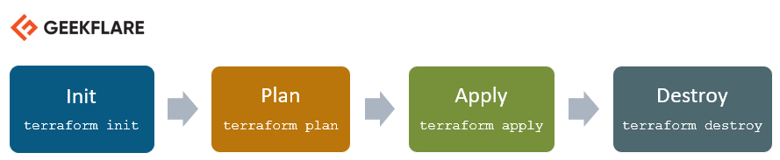

* Terraform init initializes the working directory which consists of all the configuration files
* Terraform plan is used to create an execution plan to reach a desired state of the infrastructure. Changes in the configuration files are done in order to achieve the desired state.
* Terraform apply then makes the changes in the infrastructure as defined in the plan, and the infrastructure comes to the desired state.
* Terraform destroy is used to delete all the old infrastructure resources, which are marked tainted after the apply phase.

Terraform is an infrastructure as code tool that lets you define both cloud and on-prem resources in human-readable configuration files that you can version, reuse, and share.

How does terraform works?

Terraform creates and manages resources on cloud platforms and other services through their application programming interfaces (APIs). Providers enable Terraform to work with virtually any platform or service with an accessible API.

[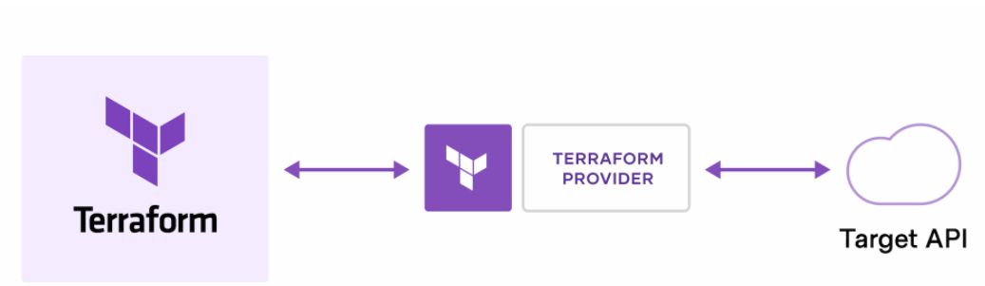](https://user-images.githubusercontent.com/90096333/179201143-4cbcc9b7-0a2d-4371-8a02-b06a2aad71fc.png)

Installation of Terraform on windows check the below link for the installtion of terraform

<https://spacelift.io/blog/how-to-install-terraform>

<https://youtu.be/Cn6xYf0QJME> ;

<https://youtu.be/cCaTsD8pRrY>

Terraform creates and manages cloud platforms and services through their APIs Terraform workflow consists of three stages: [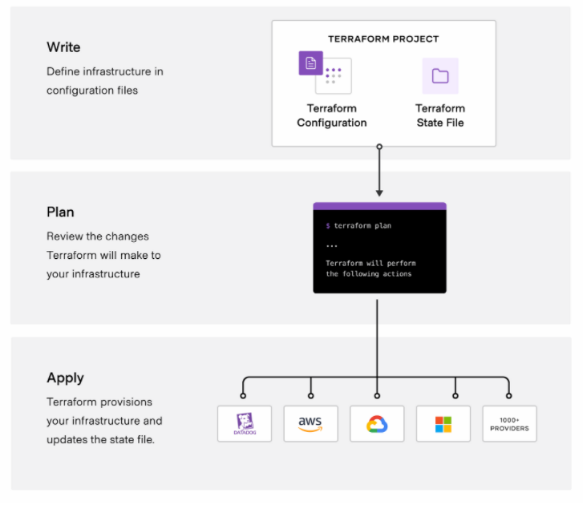](https://user-images.githubusercontent.com/90096333/179211668-773c72e5-f046-4a02-a80f-48a2e02e3813.png)

Installation of Terraform on windows check the below link for the installation of terraform

<https://spacelift.io/blog/how-to-install-terraform>

<https://youtu.be/Cn6xYf0QJME> ;

<https://youtu.be/cCaTsD8pRrY>